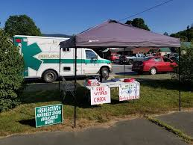  Support & Donate…  As a non-profit organization, we constantly face funding shortfalls. Our funding comes from reimbursements of patient insurances and town appropriations. Sadly, these do not come close to covering our costs. Town appropriations cover less then 15% of our costs. And, 25% of our responses are not billable; close to 50% are not collectible.  None of this matter’s when you need us – we still are here for you 24/7 when you call.  As a non-profit, your donation to us is fully tax-deductible under the law. If you need a copy of our 501(c)3 letter, please contact us.  wwasems@aol.com |  |  | WARREN - WENTWORTH AMBULANCE SERVICE  Po Box 219  Warren, NH 03279  Warren-Wentworth Ambulance Service |  |  | Affordable Community Care Program 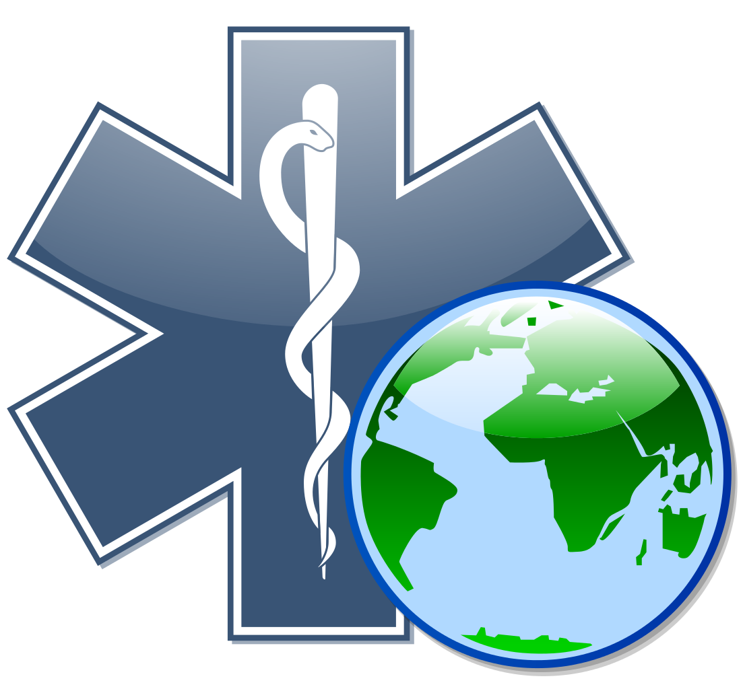  This Photo by Unknown Author is licensed under CC BY-SA  “Helping You… Help Us!”  Sponsored by:  Warren-Wentworth Ambulance  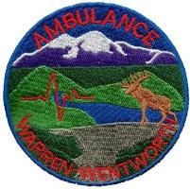  Warren-Wentworth Ambulance Service  PO Box 219  Warren, NH 03279  603-764-9494  wwasems@aol.com
Take the financial stress out of calling an ambulance…  Warren-Wentworth Ambulance Service (WWAS) understands that a medical transportation can be unexpected and a costly expense. To financially safeguard your family against unforeseen medical emergencies, WWAS now offers an affordable community care program to our 911 communities.  The affordable community care program offered through WWAS covers out of pocket expenses to our 911 communities of any medically necessary ambulance transports. Our subscription program is NOT HEALTH INSURANCE and does NOT replace your primary insurance.  In the event of a medical emergency, a subscriber’s primary insurance would be billed. Any additional balances, deductibles, or co-pays not covered by the insurance for services deemed medically necessary would be covered through WWAS affordable community care program.  Join today and let us help you protect your family’s physical and financial health in an emergency. |  |  | Subscription Information  - What is a subscription?  It is a way for the residents of the communities we serve to have a greater peace of mind and reduce out of pocket expenses associated with ambulance transportations.  - What is covered?  All emergency (911) calls in our service area and any balances remaining after all insurance plans are billed.  “Great service to the town and surrounding communities.”  - Who is covered in a family or “household” subscription?  Any individual who resides in your household.  - What if I have no insurance?  If you’re without insurance coverage, or your coverage does not provide payment for ambulance services, you will not have any out of pocket expense. |  |  | - When does coverage begin and end?  Affordable Community Care Program coverage begins January 1st and ends December 31st of each year. Subscription fees are not pro-rated.  - What if I already have insurance?  Many insurance companies do not provide full coverage for ambulance transportations, which could result in you having to pay for services out of pocket or to meet your deductible.  While enrolled into our affordable community care program, WWAS will bill your insurance and collect from them but YOU will never have to pay any additional amount.  - How much is the affordable community care program?  2021 Rates:  Household $50  Individual $35  SIGN UP TODAY!!!!  Don’t be this person…  person . . .

